Transfix

What is Transfix
# Source: AI Source: Provided by: [Data Path: Persons Table -> ID Column: 1, Name_En Column: Motasem Essam] -> From: [Chatgpt (GPT-4-turbo)] on [7/29/2025]
A transfix is a type of affix used in nonconcatenative morphology, where a pattern of vowels (or vowels and consonants) is inserted within a root—typically a consonantal root—to create different meanings or grammatical forms. Transfixation is especially common in Semitic languages like Arabic and Hebrew.

🔹 Definition of Transfix:
# Source: AI Source: Provided by: [Data Path: Persons Table -> ID Column: 1, Name_En Column: Motasem Essam] -> From: [Chatgpt (GPT-4-turbo)] on [7/29/2025]
A transfix is a discontinuous affix that is woven through the root, usually by inserting vowels into a consonantal skeleton (often triliteral). Unlike other affixes, it is not added before or after, but interleaved with the root itself.

🔹 How Transfixation Works:
# Source: AI Source: Provided by: [Data Path: Persons Table -> ID Column: 1, Name_En Column: Motasem Essam] -> From: [Chatgpt (GPT-4-turbo)] on [7/29/2025]
- The root typically consists of three consonants (called a triconsonantal root) that hold the core meaning.
- The transfix is a vowel or vowel-consonant pattern inserted within this root to form new words.

🔹 Examples from Arabic (Root: K-T-B – "writing")
# Source: AI Source: Provided by: [Data Path: Persons Table -> ID Column: 1, Name_En Column: Motasem Essam] -> From: [Chatgpt (GPT-4-turbo)] on [7/29/2025]
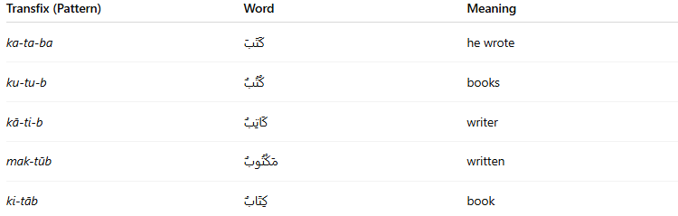
Transfix (Pattern) | Word | Meaning
ka-ta-ba | كَتَبَ | he wrote
ku-tu-b | كُتُبٌ | books
kā-ti-b | كَاتِبٌ | writer
mak-tūb | مَكْتُوبٌ | written
ki-tāb | كِتَابٌ | book
The root consonants K–T–B are constant, while the transfix changes to form different words and grammatical categories.

🔹 Features of Transfixes:
# Source: AI Source: Provided by: [Data Path: Persons Table -> ID Column: 1, Name_En Column: Motasem Essam] -> From: [Chatgpt (GPT-4-turbo)] on [7/29/2025]
- ✅ Interleaved inside a root (not attached before or after).
- ✅ Characteristic of Semitic languages (e.g., Arabic, Hebrew).
- ✅ Used for both derivation and inflection.
- ❌ Rare or non-existent in most Indo-European languages.
- ✅ Creates nonlinear word structures.

🔹 Transfix vs Other Affixes:
# Source: AI Source: Provided by: [Data Path: Persons Table -> ID Column: 1, Name_En Column: Motasem Essam] -> From: [Chatgpt (GPT-4-turbo)] on [7/29/2025]
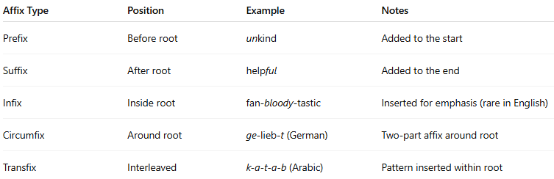

Affix Type | Position | Example | Notes
Prefix | Before root | unkind | Added to the start
Suffix | After root | helpful | Added to the end
Infix | Inside root | fan-bloody-tastic | Inserted for emphasis (rare in English)
Circumfix | Around root | ge-lieb-t (German) | Two-part affix around root
Transfix | Interleaved | k-a-t-a-b (Arabic) | Pattern inserted within root

🔹 Summary:
# Source: AI Source: Provided by: [Data Path: Persons Table -> ID Column: 1, Name_En Column: Motasem Essam] -> From: [Chatgpt (GPT-4-turbo)] on [7/29/2025]
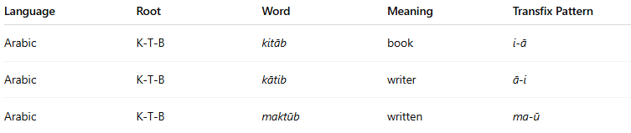

Language | Root | Word | Meaning | Transfix Pattern
Arabic | K-T-B | kitāb | book | i-ā
Arabic | K-T-B | kātib | writer | ā-i
Arabic | K-T-B | maktūb | written | ma-ū

